Zoom Background Challenge

Directions: Complete each challenge as a group. Each student should speak after each time they chance their background.

Background Challenges

1. Change your background to a scene from your favorite movie. Describe the movie and tell us why you like it.
2. Change your background to the place you would most like to travel to after COVID. Tell us why you want to go there.
3. Change your background to a picture of your favorite food. Tell us a memory you have eating this food.
4. Change your background to a picture of your favorite animal. What do you like about this animal?
5. Change your background to a picture of what you are planning to study here at GIST. Explain why this interests you.

How to Change your Zoom Background

1. [Download the Zoom app](https://zoom.us/download).
2. Open the app and sign in.   
   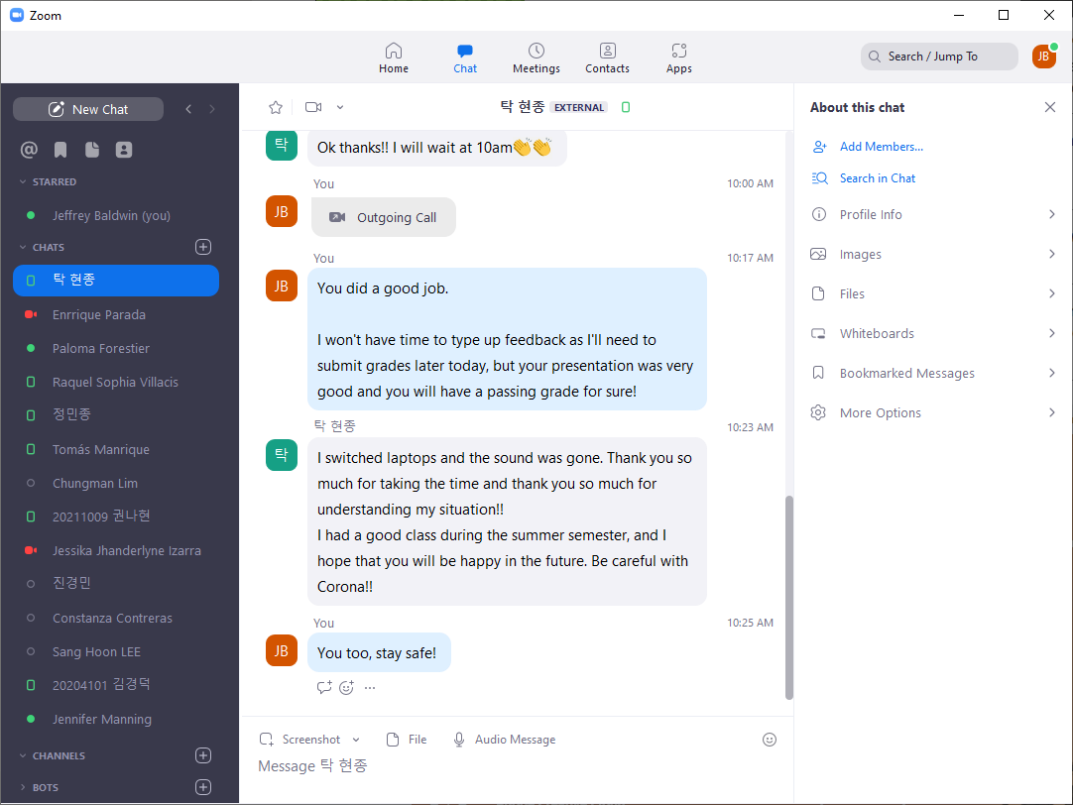
3. Click your profile picture, then click on Settings.

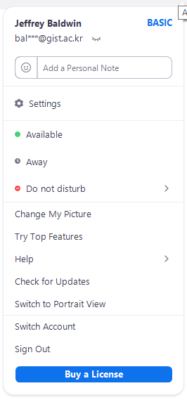

1. In the left menu bar, click on the Background & Filters  
   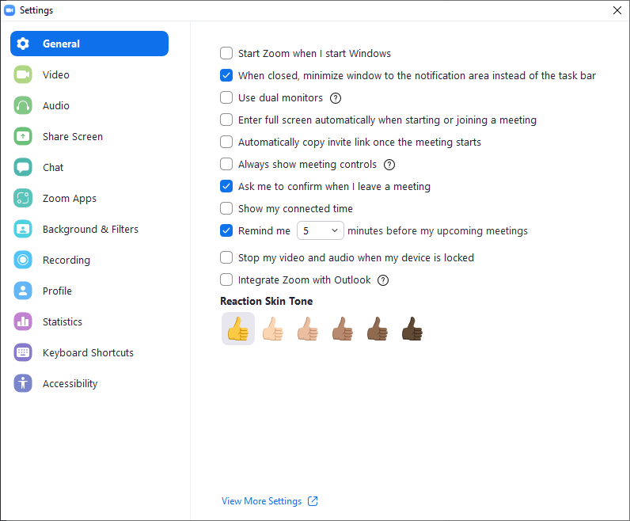
2. In the Background & Filters tab, select + to add images.
3. After adding images saved onto your computer, you may upload these images as your background.

